**PROJECT**

**TITLE OF PROJECT:** WEBSITE FOR SUPERMARKET

**GROUP MEMBER:**

1. NITESH AGRAWAL COMP A 06
2. ABHISHEK GUPTA AI&ML 15
3. ROHIT GUPTA AI&ML 17
4. VIPUL JAISWAL AI&ML 19

**OBJECTIVE OF YOUR PROJECT:** YOUR PROJECT'S TOPIC IS A WEBSITE FOR A SUPERMARKET. WE CREATED A WEBSITE FOR DIFFERENT KINDS OF NATURAL PRODUCTS THAT YOU NEED IN YOUR EVERYDAY LIFE, SUCH AS COOKING ESSENTIALS, PERSONAL AND HOME CARE, BREAKFAST AND SNACKS, AND SO ON. TO “LIVE WELL” WE NEED TO “EAT WELL”. THE NUMEROUS BENEFITS OF ORGANIC AND NATURAL PRODUCTS SIMPLY OUTWEIGH THE MARGINALLY HIGHER PRICES CONSIDERING THE INCREASED COST OF CULTIVATION. WE URGE OUR FELLOW HUMANS TO TRANSFORM THEIR HABITS TO MAXIMIZE THE ADOPTION OF ORGANIC AND NATURAL CHOICES IN OUR DAY TO DAY LIVES.

**CODE HTML AND CSS:**

**FOR MAIN PAGE:**

**Index.html**

<html>

<head>

<title>

Village Supar Market

</title>

<link rel="stylesheet" href="style.css">

<link rel="preconnect" href="https://fonts.googleapis.com">

<link rel="preconnect" href="https://fonts.gstatic.com" crossorigin>

<link rel="stylesheet" href="https://cdn.jsdelivr.net/gh/FortAwesome/Font-Awesome@5.15.3/css/all.css">

</head>

<body>

<nav id="navmain">

<nav id="navbar1">

<div class="mar">

<marquee>Super Sale is now Live! &nbsp;&nbsp;&nbsp;&nbsp;&nbsp;&nbsp; Mumbai &amp; Pune - Delivery within 2 days&nbsp; &nbsp;&nbsp;&nbsp;&nbsp; Cash on delivery available</marquee>

</div>

<div class="socials">

<div class="social">

<a href="https://www.facebook.com/"><i class="fab fa-facebook"></i></a>

</div>

<div class="social">

<a href="https://www.instagram.com/"><i class="fab fa-instagram"></i></a>

</div>

<div class="social">

<a href="https://www.twitter.com/"><i class="fab fa-twitter"></i></a>

</div>

</div>

</nav>

<nav id="navbar2">

<div>

<div class="logo">

<img src="imghome\logo.jpg" alt="">

</div>

<div class="pin">

<a href="index.html"><img src="imghome\lo.png" alt=""> Select pincode</a>

</div>

<div class="search">

<form action="">

<input type="text" required placeholder="What you looking for today?">

<button class="btn btn-theme" id="search" type="submit" value="submit"><a href="#"><i class="fas fa-search"></i></a></button>

</form>

</div>

</div>

<div>

<div class="carts">

<a href="#"><i class="fas fa-heart"></i></a>

<a href="#"><i class="fas fa-shopping-cart"></i></a>

</div>

<div class="login">

<a href="login.html">Login</a>

<a href="signup.html">Sign up</a>

</div>

</div>

</nav>

<nav id="navbar3">

<div class="category">

<a href="#Categories">Shop By Category</a>

</div>

<div class="button">

<ul>

<li class="con"><a href="#concern"><span>Shop By Concern</span></a></li>

<li class="home"><a href="index.html"><span>Home</span></a></li>

<li class="about"><a href="about.html"><span>About Us</span></a></li>

<li class="blog"><a href="blog.html"><span>Blogs&Recipes</span></a></li>

<li class="contact"><a href="contact.html"><span>Contact Us</span></a></li>

</ul>

</div>

</nav>

</nav>

<section id="hom">

<div style="height: 30vh;"></div>

<div class="backimg">

<!-- <img src="back1.jpg" alt=""> -->

</div>

</section>

<section id="Categories">

<h1 class="h-primary center">Shop by Categories</h1>

<div class="category-img">

<div class="catimg">

<div class="cat">

<a href="cooking.html"><img src="imghome\cook.jpg" alt=""></a>

</div>

<div class="cat">

<a href="personal.html"><img src="imghome\personal.jpg" alt=""></a>

</div>

<div class="cat">

<a href="tea.html"><img src="imghome\tea.jpg" alt=""></a>

</div>

</div>

<div class="catimg">

<div class="cat">

<a href="dry.html"><img src="imghome\dry fruits.jpg" alt=""></a>

</div>

<div class="cat">

<a href="breakfast.html"><img src="imghome\snacks.jpg" alt=""></a>

</div>

<div class="cat">

<a href="vegetable.html"><img src="imghome\veg.png" alt=""></a>

</div>

</div>

</div>

</section>

<section id="concern">

<h1 class="h-primary center">Shop by Concern</h1>

<div class="concern-img">

<div class="con">

<h2 class="h-secondary center"><a href="diabetes.html"><img src="imghome\diabetes.jpeg" alt=""><br>Diabetes</a></h2>

</div>

<div class="con">

<h2 class="h-secondary center"><a href="digestion.html"><img src="imghome\digestion.jpeg" alt=""><br>Digestion</a></h2>

</div>

<div class="con">

<h2 class="h-secondary center"><a href="immunity.html"><img src="imghome\immunity.jpeg" alt=""><br>Immunity</a></h2>

</div>

<div class="con">

<h2 class="h-secondary center"><a href="gluten.html"><img src="imghome\free.jpeg" alt=""><br>Gluten Free</a></h2>

</div>

<div class="con">

<h2 class="h-secondary center"><a href="skin.html"><img src="imghome\care.jpeg" alt=""><br>Skin & Hair Care</a></h2>

</div>

</div>

</section>

<section id="products">

<h1 class="h-primary">Top Featured Products</h1>

<div class="product">

<div class="box">

<h3 class="h-primary carts"><span>Natural</span><a href="#"><i class="fas fa-heart"></i></a></h3>

<div class="box-img">

<a href="#">

<img src="imghome\f1.jpg" alt=""><br>Nutriorg

</a></div>

<div>

<h3 class="h-primary">Nutriorg Immunity Booster Jucies</h3>

<h3>500ml</h3>

<h3>MRP Rs<strike>540</strike> Rs385</h3>

</div>

<div>

<a class="add" href="#">Add To Cart</a>

</div>

</div>

<div class="box">

<h3 class="h-primary carts"><span>Natural</span><a href="#"><i class="fas fa-heart"></i></a></h3>

<div class="box-img">

<a href="#">

<img src="imghome\f2.jpg" alt=""><br>Mamaearth

</a></div>

<div>

<h3 class="h-primary">Vitamin C Face Wash With Vitamin C</h3>

<h3>100ml</h3>

<h3>MRP Rs<strike>249</strike> Rs234</h3>

</div>

<div >

<a class="add" href="#">Add To Cart</a>

</div>

</div>

<div class="box">

<h3 class="h-primary carts"><span>Natural</span><a href="#"><i class="fas fa-heart"></i></a></h3>

<div class="box-img">

<a href="#">

<img src="imghome\f3.jpg" alt=""><br>Organic Harvest

</a></div>

<div>

<h3 class="h-primary">Lip Balm-<br>Strawberry</h3>

<h3>8gm</h3>

<h3>MRP Rs<strike>199</strike> Rs187</h3>

</div>

<div>

<a class="add" href="#">Add To Cart</a>

</div>

</div>

<div class="box">

<h3 class="h-primary carts"><span>Natural</span><a href="#"><i class="fas fa-heart"></i></a></h3>

<div class="box-img">

<a href="#">

<img src="imghome\f4.jpg" alt=""><br>Udyan Tea

</a></div>

<div>

<h3 class="h-primary">Udyan Tea-Kadak Masala Chai</h3>

<h3>100gm</h3>

<h3>MRP Rs<strike>249</strike> Rs234</h3>

</div>

<div>

<a class="add" href="#">Add To Cart</a>

</div>

</div>

<!-- <div class="box">

<h3 class="h-primary carts"><span>Natural</span><a href="#"><i class="fas fa-heart"></i></a></h3>

<div class="box-img">

<a href="#">

<img src="imghome\f1.jpg" alt=""><br>Nutriorg

</a></div>

<div>

<h3 class="h-primary">Nutriorg Immunity Booster Jucies</h3>

<h3>500ml</h3>

<h3>MRP Rs<strike>540</strike> Rs385</h3>

</div>

<div>

<a class="add" href="#">Add To Cart</a>

</div>

</div> -->

</div>

</section>

<section id="Subscribe">

<div class="newbrand">

<div class="footlabel">

<img src="imghome\shipping.png" alt="">

<div class="label">

<h5><b>Free Shipping</b></h5>

<label>On All Orders above INR 399/-</label>

</div>

</div>

<div class="footlabel">

<img src="imghome\payment.png" alt="">

<div class="label">

<h5><b>Secure Payments</b></h5>

<label>Your payments are safe with us</label>

</div>

</div>

<div class="footlabel">

<img src="imghome\call.png" alt="">

<div class="label">

<h5><b>Quick Support</b></h5>

<label>Chat / Call / E-Mail</label>

</div>

</div>

</div>

<div class="update">

<div class="single">

<p>Stay updated on latest offers</p>

<div class="input-group">

<form action="">

<input id="leadgenaration" type="email" name="" class="form-control" required placeholder="Enter your email" pattern="[a-z0-9._%+-]+@[a-z0-9.-]+\.[a-z]{2,4}$">

<button class="btn1 btn-theme" id="sub" type="submit" value="subscribe">Subscribe</button>

</form>

</div>

</div>

</div>

</section>

<section id="last">

<div class="row">

<div class="second-row-item">

<a href="index.html"><img src="imghome\logo.jpg"></a>

<p>Village SuperMarket brings to you a wide range of Groceries and natural products under one roof. We deliver our carefully curated selection across Mumbai. </p>

</div>

<div class="linknapp">

<div class="second-row-item-link">

<h4>Important Links</h4>

<div class="all-link">

<ul class="linklist">

<li><a href="about.html">About Us</a></li>

<li><a href="blog.html">Blogs & Recipes</a></li>

<li><a href="contact.html">Contact Us</a></li>

<li><a href="faq.html">FAQs</a></li>

<li><a href="careers.html">Careers</a></li>

<li class="partner"><a href="#" data-toggle="modal" data-target="#partnerpopup">Partner with us</a></li>

</ul>

<ul class="linklist">

<li><a href="terms.html">Terms & Conditions</a></li>

<li><a href="shipping.html">Shipping & Delivery policy</a></li>

<li><a href="refund.html">Refund, Return & Cancellation Policy</a></li>

<li><a href="privacy.html">Privacy Policy</a></li>

<li><a href="coupon.html" >Coupon Partners</a></li>

</ul>

</div>

</div>

<div class="second-row-item-app">

<h4>Coming Soon</h4>

<div class="downloadapp">

<img class="download-btn" src="imghome\apple.png" alt="">

<img class="download-btn1" src="imghome\google.png" alt="">

</div>

<div class="footer-payments">

<h4>Your payments are secured</h4>

<img src="imghome\pay.png">

</div>

</div>

</div>

</div>

</section>

<footer>

<div class="footer">

<div class="center">

Copyright &copy; www.SuperMarket.com.!!

</div>

</div>

</footer>

</body>

</html>

**about.html**

<html>

<head>

<title>

About Us

</title>

<link rel="stylesheet" href="style.css">

<link rel="stylesheet" href="cooking.css">

<link rel="preconnect" href="https://fonts.googleapis.com">

<link rel="preconnect" href="https://fonts.gstatic.com" crossorigin>

<link rel="stylesheet" href="https://cdn.jsdelivr.net/gh/FortAwesome/Font-Awesome@5.15.3/css/all.css">

</head>

<body>

<nav id="navmain">

<nav id="navbar1">

<div class="mar">

<marquee>Super Sale is now Live! &nbsp;&nbsp;&nbsp;&nbsp;&nbsp;&nbsp; Mumbai &amp; Pune - Delivery within 2 days&nbsp; &nbsp;&nbsp;&nbsp;&nbsp; Cash on delivery available</marquee>

</div>

<div class="socials">

<div class="social">

<a href="https://www.facebook.com/"><i class="fab fa-facebook"></i></a>

</div>

<div class="social">

<a href="https://www.instagram.com/"><i class="fab fa-instagram"></i></a>

</div>

<div class="social">

<a href="https://www.twitter.com/"><i class="fab fa-twitter"></i></a>

</div>

</div>

</nav>

<nav id="navbar2">

<div>

<div class="logo">

<img src="imghome\logo.jpg" alt="">

</div>

<div class="pin">

<a href="index.html"><img src="imghome\lo.png" alt=""> Select pincode</a>

</div>

<div class="search">

<form action="">

<input type="text" required placeholder="What you looking for today?">

<button class="btn btn-theme" id="search" type="submit" value="submit"><a href="#"><i class="fas fa-search"></i></a></button>

</form>

</div>

</div>

<div>

<div class="carts">

<a href="#"><i class="fas fa-heart"></i></a>

<a href="#"><i class="fas fa-shopping-cart"></i></a>

</div>

<div class="login">

<a href="login.html">Login</a>

<a href="signup.html">Sign up</a>

</div>

</div>

</nav>

<nav id="navbar3">

<div class="category">

<a href="Categories">Shop By Category</a>

</div>

<div class="button">

<ul>

<li class="con"><a href="concern"><span>Shop By Concern</span></a></li>

<li class="home"><a href="index.html"><span>Home</span></a></li>

<li class="about"><a href="about.html"><span>About Us</span></a></li>

<li class="blog"><a href="blog.html"><span>Blogs&Recipes</span></a></li>

<li class="contact"><a href="contact.html"><span>Contact Us</span></a></li>

</ul>

</div>

</nav>

</nav>

<section>

<div style="height: 35vh;"></div>

<div class="aboutus">

<div class="">

<div class="title left-text">

<h2>About Village Super Market</h2>

</div>

<div class="about-content">

<p><p style="text-align:justify">&nbsp;</p>

<p style="text-align:justify"><span style="font-size:16px">

<strong><img class="second-row-item" src="imghome/logo.jpg" style="float:right; height:200px; width:330px" /></strong></span>

<span style="font-size:22px"><strong>Our Story</strong></span></p>

<p style="text-align:justify">&nbsp;</p>

<p style="text-align:justify"><span style="font-size:18px"><strong>2021 &ndash; The Year it all began</strong></span></p>

<p style="text-align:justify">&nbsp;</p>

<p style="text-align:justify"><span style="font-size:16px">The COVID-19 pandemic changed our lives. </span></p>

<p style="text-align:justify"><span style="font-size:16px">We understood the importance of leading a healthy lifestyle and being

free of any health issues or co-morbidities. </span></p>

<p style="text-align:justify"><span style="font-size:16px">It gave us a chance to take a pause and reflect upon our food choices. </span></p>

<p style="text-align:justify"><span style="font-size:16px">We started cooking ourselves and realized that when we chose convenience foods we

had a high price to pay even though the labels signalled otherwise. We saw first-hand how easily accessible convenience foods from the

processed food industry rank very low in nutritional value and contain immense amounts of artificial ingredients. Many of these are responsible

for several health issues our generation faces. </span></p>

<p style="text-align:justify"><span style="font-size:16px">We then started choosing products which are free from&nbsp;chemicals / pesticides

and other harmful additives. Very soon we realized they were not very easily accessible. We wanted to solve this.&nbsp; </span></p>

<p style="text-align:justify"><span style="font-size:16px">We strongly believe that the world needs to switch to organic and natural products

to ensure sustained wellness for our bodies while protecting our planet. It is vital to restore the balance which has been disrupted. It needs

to be done to safeguard ourselves as well as our future generations. </span></p>

<p style="text-align:justify"><span style="font-size:16px">To <strong>&ldquo;Live well&rdquo; </strong>we need to <strong>&ldquo;Eat Well&rdquo;</strong>.

The numerous benefits of organic and natural products simply outweigh the marginally higher prices considering the increased cost of cultivation. We urge our

fellow humans to transform their habits to maximize the adoption of organic and natural choices in our day to day lives. </span></p>

<p style="text-align:justify"><em><strong><span style="font-size:18px">We wish to contribute to this transformation!&nbsp;</span></strong></em></p>

</p>

<p style="text-align:justify"><span style="font-size:20px"><em><strong>This site created by Nitesh, Abhishek, Rohit, Vipul.</strong></em> </span></p>

</div>

</div>

</div>

</section>

<section id="Subscribe">

<div class="newbrand">

<div class="footlabel">

<img src="imghome\shipping.png" alt="">

<div class="label">

<h5><b>Free Shipping</b></h5>

<label>On All Orders above INR 399/-</label>

</div>

</div>

<div class="footlabel">

<img src="imghome\payment.png" alt="">

<div class="label">

<h5><b>Secure Payments</b></h5>

<label>Your payments are safe with us</label>

</div>

</div>

<div class="footlabel">

<img src="imghome\call.png" alt="">

<div class="label">

<h5><b>Quick Support</b></h5>

<label>Chat / Call / E-Mail</label>

</div>

</div>

</div>

<div class="update">

<div class="single">

<p>Stay updated on latest offers</p>

<div class="input-group">

<form action="">

<input id="leadgenaration" type="email" name="" class="form-control" required placeholder="Enter your email" pattern="[a-z0-9._%+-]+@[a-z0-9.-]+\.[a-z]{2,4}$">

<button class="btn1 btn-theme" id="sub" type="submit" value="subscribe">Subscribe</button>

</form>

</div>

</div>

</div>

</section>

<section id="last">

<div class="row">

<div class="second-row-item">

<a href="index.html"><img src="imghome\logo.jpg"></a>

<p>Village SuperMarket brings to you a wide range of Groceries and natural products under one roof. We deliver our carefully curated selection across Mumbai. </p>

</div>

<div class="linknapp">

<div class="second-row-item-link">

<h4>Important Links</h4>

<div class="all-link">

<ul class="linklist">

<li><a href="about.html">About Us</a></li>

<li><a href="blog.html">Blogs & Recipes</a></li>

<li><a href="contact.html">Contact Us</a></li>

<li><a href="faq.html">FAQs</a></li>

<li><a href="careers.html">Careers</a></li>

<li class="partner"><a href="#" data-toggle="modal" data-target="#partnerpopup">Partner with us</a></li>

</ul>

<ul class="linklist">

<li><a href="terms.html">Terms & Conditions</a></li>

<li><a href="shipping.html">Shipping & Delivery policy</a></li>

<li><a href="refund.html">Refund, Return & Cancellation Policy</a></li>

<li><a href="privacy.html">Privacy Policy</a></li>

<li><a href="coupon.html" >Coupon Partners</a></li>

</ul>

</div>

</div>

<div class="second-row-item-app">

<h4>Coming Soon</h4>

<div class="downloadapp">

<img class="download-btn" src="imghome\apple.png" alt="">

<img class="download-btn1" src="imghome\google.png" alt="">

</div>

<div class="footer-payments">

<h4>Your payments are secured</h4>

<img src="imghome\pay.png">

</div>

</div>

</div>

</div>

</section>

<footer>

<div class="footer">

<div class="center">

Copyright &copy; www.SuperMarket.com.!!

</div>

</div>

</footer>

</body>

</html>

**FOR BLOGS & RECIPES**

**Blog.html**

<html>

<head>

<title>

Blogs & recipes

</title>

<link rel="stylesheet" href="style.css">

<link rel="preconnect" href="https://fonts.googleapis.com">

<link rel="preconnect" href="https://fonts.gstatic.com" crossorigin>

<link rel="stylesheet" href="https://cdn.jsdelivr.net/gh/FortAwesome/Font-Awesome@5.15.3/css/all.css">

</head>

<body>

<nav id="navmain">

<nav id="navbar1">

<div class="mar">

<marquee>Super Sale is now Live! &nbsp;&nbsp;&nbsp;&nbsp;&nbsp;&nbsp; Mumbai &amp; Pune - Delivery within 2 days&nbsp; &nbsp;&nbsp;&nbsp;&nbsp; Cash on delivery available</marquee>

</div>

<div class="socials">

<div class="social">

<a href="https://www.facebook.com/"><i class="fab fa-facebook"></i></a>

</div>

<div class="social">

<a href="https://www.instagram.com/"><i class="fab fa-instagram"></i></a>

</div>

<div class="social">

<a href="https://www.twitter.com/"><i class="fab fa-twitter"></i></a>

</div>

</div>

</nav>

<nav id="navbar2">

<div>

<div class="logo">

<img src="imghome\logo.jpg" alt="">

</div>

<div class="pin">

<a href="index.html"><img src="imghome\lo.png" alt=""> Select pincode</a>

</div>

<div class="search">

<form action="">

<input type="text" required placeholder="What you looking for today?">

<button class="btn btn-theme" id="search" type="submit" value="submit"><a href="#"><i class="fas fa-search"></i></a></button>

</form>

</div>

</div>

<div>

<div class="carts">

<a href="#"><i class="fas fa-heart"></i></a>

<a href="#"><i class="fas fa-shopping-cart"></i></a>

</div>

<div class="login">

<a href="login.html">Login</a>

<a href="signup.html">Sign up</a>

</div>

</div>

</nav>

<nav id="navbar3">

<div class="category">

<a href="#Categories">Shop By Category</a>

</div>

<div class="button">

<ul>

<li class="con"><a href="#concern"><span>Shop By Concern</span></a></li>

<li class="home"><a href="index.html"><span>Home</span></a></li>

<li class="about"><a href="about.html"><span>About Us</span></a></li>

<li class="blog"><a href="blog.html"><span>Blogs&Recipes</span></a></li>

<li class="contact"><a href="contact.html"><span>Contact Us</span></a></li>

</ul>

</div>

</nav>

</nav>

<section id="blogs">

<div style="height: 30vh;"></div>

<div class="recipes">

<div class="recipe">

<div class="recipeimg">

<img src="imghome/recipe.jpg" alt="">

</div>

<div class="info">

<h3>Ajwain - A Wonder Herb</h3>

<p>Mrs. Gouri David (Dietician & Nutritionist)</p>

<a href="#">Read more</a>

</div>

</div>

<div class="recipe">

<div class="recipeimg">

<img src="imghome/recipe2.jpeg" alt="">

</div>

<div class="info">

<h3>Diabetes Mellitus</h3>

<p>Mrs. Gouri David (Consultant Dietician)</p>

<a href="#">Read more</a>

</div>

</div>

<div class="recipe">

<div class="recipeimg">

<img src="imghome/recipe3.png" alt="">

</div>

<div class="info">

<h3>Importance of a nutritious diet for Mothers and Children</h3>

<p>By Dr Meenakshi</p>

<a href="#">Read more</a>

</div>

</div>

<div class="recipe">

<div class="recipeimg">

<img src="imghome/recipe4.png" alt="">

</div>

<div class="info">

<h3>Why should we choose Organic and Natural products?</h3>

<p>By Dr Meenakshi</p>

<a href="#">Read more</a>

</div>

</div>

</div>

</section>

<section id="Subscribe">

<div class="newbrand">

<div class="footlabel">

<img src="imghome\shipping.png" alt="">

<div class="label">

<h5><b>Free Shipping</b></h5>

<label>On All Orders above INR 399/-</label>

</div>

</div>

<div class="footlabel">

<img src="imghome\payment.png" alt="">

<div class="label">

<h5><b>Secure Payments</b></h5>

<label>Your payments are safe with us</label>

</div>

</div>

<div class="footlabel">

<img src="imghome\call.png" alt="">

<div class="label">

<h5><b>Quick Support</b></h5>

<label>Chat / Call / E-Mail</label>

</div>

</div>

</div>

<div class="update">

<div class="single">

<p>Stay updated on latest offers</p>

<div class="input-group">

<form action="">

<input id="leadgenaration" type="email" name="" class="form-control" required placeholder="Enter your email" pattern="[a-z0-9._%+-]+@[a-z0-9.-]+\.[a-z]{2,4}$">

<button class="btn1 btn-theme" id="sub" type="submit" value="subscribe">Subscribe</button>

</form>

</div>

</div>

</div>

</section>

<section id="last">

<div class="row">

<div class="second-row-item">

<a href="index.html"><img src="imghome\logo.jpg"></a>

<p>Village SuperMarket brings to you a wide range of Groceries and natural products under one roof. We deliver our carefully curated selection across Mumbai. </p>

</div>

<div class="linknapp">

<div class="second-row-item-link">

<h4>Important Links</h4>

<div class="all-link">

<ul class="linklist">

<li><a href="about.html">About Us</a></li>

<li><a href="blog.html">Blogs & Recipes</a></li>

<li><a href="contact.html">Contact Us</a></li>

<li><a href="faq.html">FAQs</a></li>

<li><a href="careers.html">Careers</a></li>

<li class="partner"><a href="#" data-toggle="modal" data-target="#partnerpopup">Partner with us</a></li>

</ul>

<ul class="linklist">

<li><a href="terms.html">Terms & Conditions</a></li>

<li><a href="shipping.html">Shipping & Delivery policy</a></li>

<li><a href="refund.html">Refund, Return & Cancellation Policy</a></li>

<li><a href="privacy.html">Privacy Policy</a></li>

<li><a href="coupon.html" >Coupon Partners</a></li>

</ul>

</div>

</div>

<div class="second-row-item-app">

<h4>Coming Soon</h4>

<div class="downloadapp">

<img class="download-btn" src="imghome\apple.png" alt="">

<img class="download-btn1" src="imghome\google.png" alt="">

</div>

<div class="footer-payments">

<h4>Your payments are secured</h4>

<img src="imghome\pay.png">

</div>

</div>

</div>

</div>

</section>

<footer>

<div class="footer">

<div class="center">

Copyright &copy; www.SuperMarket.com.!!

</div>

</div>

</footer>

</body>

</html>

**style.css**

*{

margin: 0;

padding: 0;

}

/* home */

#hom{

height: 100vh;

}

#navmain{

align-items: center;

position: fixed;

top: 0px;

width: 100%;

/* background-image: linear-gradient(to right top, #91e84f, #66e079, #46d698, #43c9ad, #5bbab4); */

background-image: linear-gradient(to right top, #051937, #004d7a, #008793, #00bf72, #a8eb12);

font-family: 'Baloo Bhaina 2', cursive;

/* font-family: 'PT Sans', sans-serif; */

z-index: 2;

}

#navbar1{

display: flex;

align-items: center;

height: 7.5vh;

justify-content: space-around;

}

#navbar2{

display: flex;

align-items: center;

height: 15vh;

justify-content: space-around;

background: white;

}

#navbar2 div{

display: flex;

align-items: center;

margin: 1rem;

}

#navbar2 div .pin a{

text-decoration: none;

}

#navbar3{

display: flex;

align-items: center;

height: 7.5vh;

justify-content: space-around;

background: #fff;

}

.search,.search input{

flex: 1 0 auto;

outline: 0;

background: rgba(236, 240, 237, 0.4);

border: 1px solid rgba(34,36,38,.15);

color: rgba(0,0,0,.87);

border-radius: 4rem;

}

.search input{

border: none;

padding: 0.5rem;

border-radius: 2rem;

/* border: 0!important; */

-ms-flex: 1 0 auto;

flex: 1 0 auto;

outline: 0;

font-family: 'Baloo Bhaina 2', cursive;

}

#navbar3 ul{

display: flex;

}

#navbar3 ul li{

list-style-type: none;

font-size: 1.2rem;

}

#navbar3 ul li a{

display: block;

padding: 1px 20px;

text-decoration: none;

margin: 10px;

border-radius: 8px;

}

.btn{

font-weight: 400;

color: #212529;

text-align: center;

vertical-align: middle;

background-color: transparent;

border: 1px solid transparent;

padding: .375rem .75rem;

font-size: 20px;

line-height: 1.5;

border-radius: .25rem;

cursor: pointer;

}

marquee {

right: 30%;

text-align: center;

font-weight: 700;

font-size: 15px;

padding: 0;

padding-top: 9px;

display: flex;

align-items: center;

color: white;

}

.socials{

display: flex;

}

.social a,.carts a{

display: flex;

background: #e3f7ed;

height: 35px;

width: 35px;

margin: 0 15px;

border-radius: 8px;

align-items: center;

justify-content: center;

text-decoration: none;

/* box-shadow: 6px 6px 10px -1px rgba(0,0,0,0.15), -6px -6px 10px -1px rgba(255,255,255,0.7); */

border: 1px solid rgba(0,0,0,0.0);

transition: transform 0.5s ease-in-out;

}

.social a i{

font-size: 30px;

color: #777;

transition: transform 0.5s ease-in-out;

}

.carts a i{

font-size: 20px;

color: #777;

transition: transform 0.5s ease-in-out;

}

.social a:hover{

box-shadow: inset 4px 4px 6px -1px rgba(0,0,0,0.2),

inset -4px -4px 6px -1px rgba(255,255,255,0.7),

-0.5px -0.5px 0px rgba(255,255,255,1),

0.5px 0.5px 0px rgba(0,0,0,0.15),

0px 12px 10px -10px rgba(0,0,0,0.05);

border: 1px solid rgba(0,0,0,0.01);

transform: translateY(2px);

}

.social a:hover i,.carts a:hover i{

transform: scale(0.90);

}

.social a:hover .fa-facebook,.carts a:hover .fa-shopping-cart{

color: #3b5998;

}

.social a:hover .fa-twitter{

color: #00acee;

}

.social a:hover .fa-instagram,.carts a:hover .fa-heart{

color: #f14843;

}

.pin a img{

height: 20px;

border: 50%;

}

.pin a{

display: flex;

align-items: center;

text-align: center;

text-decoration: none;

color: black;

font-size: small;

}

.logo img{

height: 100px;

}

.carts img{

height: 30px;

padding: 0.5rem;

}

.carts{

padding: 0.5rem;

}

.login a:hover,.pin a:hover{

color: tomato;

}

.backimg img{

width: 100%;

height: 65vh;

}

.login a{

text-decoration: none;

padding: 0.2rem;

}

.category a{

text-decoration: none;

padding: 0.7rem;

background-image: linear-gradient(to right top, #051937, #004d7a, #008793, #00bf72, #a8eb12);

font-size: 1.5rem;

border-radius: 5px;

color: white;

}

.button ul li a{

padding: 20px 30px;

text-decoration: none;

/* text-transform: uppercase; */

font-weight: 500;

/* letter-spacing: 2px; */

color: black;

font-size: 18px;

border-radius: 40px;

box-shadow: -2px -2px 8px rgba(255,255,255,1),-2px -2px 12px rgba(255,255,255,0.5),inset 2px 2px 4px rgba(255,255,255,0.1),2px 2px 8px rgba(0,0,0,0.15);

}

.button ul li a span{

transition: all 0.6s ease-in-out;

}

.button ul li a:hover{

box-shadow: inset -2px -2px 8px rgba(255,255,255,1),inset -2px -2px 12px rgba(255,255,255,0.5),inset 2px 2px 4px rgba(255,255,255,0.1),inset 2px 2px 8px rgba(0,0,0,0.15);

}

.button ul li a:hover span{

display: inline-block;

transform: scale(0.98);

color: red;

}

.backimg::before{

content: "";

background: url("back1.jpg") no-repeat center center/cover;

position: absolute;

height: 65vh;

width: 100%;

z-index: -1;

animation: test 20s infinite linear;

}

@keyframes test {

0%,10%,20%{

background-image: url("back1.jpg");

}

30%,40%,50%,60%{

background-image: url("back2.png");

}

70%,80%,90%{

background-image: url("back3.jpg");

}

100%{

background-image: url("back1.jpg");

}

}

/* Shop by Categories */

#Categories{

height: 100vh;

}

#Categories .h-primary,#concern .h-primary

{

color: red;

font-family: 'Baloo Bhaina 2', cursive;

text-decoration: underline;

}

.category-img{

padding: 40px;

}

.catimg{

display: flex;

justify-content: center;

}

.cat img{

height: 300px;

margin-left: 37px;

}

.center{

text-align: center;

}

/* concern */

#concern{

height: 60vh;

}

.concern-img{

display: flex;

justify-content: center;

}

.con h2 a{

justify-content: center;

}

.con img{

height: 180px;

margin: 3rem;

}

.h-secondary a{

text-decoration: none;

font-family: 'Baloo Bhaina 2', cursive;

color: black;

font-size: medium;

}

/* Product */

#products{

height: 70vh;

font-family: 'Baloo Bhaina 2', cursive;

}

.product{

display: flex;

justify-content: space-around;

}

.box{

margin: 20px;

padding: 20px;

box-shadow: inset 0 0 5px grey;

justify-content: center;

text-align: center;

font-family: 'Baloo Bhaina 2', cursive;

border: 1px solid black;

border-radius: 12px;

width: 17rem;

}

.box .carts{

display: flex;

justify-content: space-between;

}

.box-img a {

text-decoration: none;

color: black;

transition: transform .5s ease;

}

.box-img a img:hover {

animation: shake 0.5s infinite;

}

@keyframes shake {

0% { transform: translate(1px, 1px) rotate(0deg); }

10% { transform: translate(-1px, -2px) rotate(-1deg); }

20% { transform: translate(-3px, 0px) rotate(1deg); }

30% { transform: translate(3px, 2px) rotate(0deg); }

40% { transform: translate(1px, -1px) rotate(1deg); }

50% { transform: translate(-1px, 2px) rotate(-1deg); }

60% { transform: translate(-3px, 1px) rotate(0deg); }

70% { transform: translate(3px, 1px) rotate(-1deg); }

80% { transform: translate(-1px, -1px) rotate(1deg); }

90% { transform: translate(1px, 2px) rotate(0deg); }

100% { transform: translate(1px, -2px) rotate(-1deg); }

}

.add{

background-color:rgb(254,1,1);

border: 1px solid rgb(254,1,1);

text-decoration-style: none;

text-decoration: none;

color: white;

border-radius: 7px;

padding: 3px;

}

.box-img a img{

height: 200px;

}

.box .carts{

display: flex;

justify-content: space-between;

}

.carts span{

background: #e3f7ed;

color: #777;

padding: 0.4rem;

border-radius: 8px;

text-align: center;

}

/* Subscribe */

#Subscribe{

background: url("Subscribe.png") no-repeat center center/cover;

font-family: 'Baloo Bhaina 2', cursive;

/* font-family: 'PT Sans', sans-serif; */

/* height: 40vh; */

}

.input-group {

border-top-right-radius: 0;

border-bottom-right-radius: 0;

display: flex;

}

.single p{

font-size: 2rem;

color: darkred;

}

.single .form-control {

height: 50px;

background: rgba(255,255,255,.6);

border-radius: 20px 0 0 20px;

}

.form-control{

border-top-right-radius: 0;

border-bottom-right-radius: 0;

width: 100%;

padding: .375rem .75rem;

font-size: 1rem;

font-weight: 400;

line-height: 1.5;

color: #495057;

background-color: #fff;

background-clip: padding-box;

border: 1px solid #ced4da;

}

#leadgenaration {

display: inline-block;

cursor: text;

margin: 0em;

padding: 1px 20px;

width: 25rem;

flex: 1 0 auto;

outline: 0;

font-family: 'Baloo Bhaina 2', cursive;

}

.btn1{

height: 50px;

background-image: linear-gradient(to right top, #051937, #004d7a, #008793, #00bf72, #a8eb12);

border-radius: 0px 20px 20px 0px;

color: #fff;

border: none;

font-family: 'Baloo Bhaina 2', cursive;

padding: 1rem;

letter-spacing: 2px;

transition: all 0.5s ease-in-out;

}

.btn1:hover {

color: #d8eba3;

display: inline-block;

}

.newbrand{

display: flex;

justify-content: space-around;

padding: 5rem;

margin: 0rem;

padding-top: 2rem;

}

.footlabel{

display: flex;

}

.footlabel img{

height: 50px;

}

.single{

display: flex;

flex-direction: column;

align-items: center;

justify-content: space-evenly;

text-align: center;

padding-bottom: 6rem;

}

/* last */

.row{

display: flex;

align-items: center;

background-color: rgba(0,0,0,.07);

font-family: 'Baloo Bhaina 2', cursive;

}

.second-row-item{

flex: 1;

text-align: center;

font-family: 'Baloo Bhaina 2', cursive;

padding: 1rem;

margin: 2rem;

font-size: small;

/* background: linear-gradient(to right top, #91e84f, #66e079, #46d698, #43c9ad, #5bbab4); */

background-image: linear-gradient(to right top, #051937, #004d7a, #008793, #00bf72, #a8eb12);

}

.second-row-item p{

color: #e3f7ed;

}

.second-row-item a img{

height: 150px;

}

.linknapp{

display: flex;

flex: 3;

}

.second-row-item-link{

flex: 1;

}

.second-row-item-link h4{

font-family: 'Baloo Bhaina 2', cursive;

padding: 1rem;

font-size: large;

text-decoration: underline;

text-decoration-color: #20CD78;

}

.all-link{

display: flex;

}

.linklist{

list-style-type: '>';

}

.linklist li a{

text-decoration: none;

color: #495057;

font-size: medium;

/* padding: 1rem; */

margin: 2rem;

transition: all 0.4s ease-in-out;

}

.linklist li a:hover{

color: tomato;

}

/* footor */

.footer{

font-family: 'Baloo Bhaina 2', cursive;

background-color: black;

color: white;

padding: 6px 20px;

font-size: small;

}

/* about us & blog */

.aboutus,.recipes{

font-family: 'Baloo Bhaina 2', cursive;

font-size: larger;

padding: 2rem 8rem 2rem 8rem;

}

.about-content{

color: #777;

}

.recipeimg img{

height: 350px;

}

.recipeimg,.info{

margin: 20px;

padding: 20px;

box-shadow: inset 0 0 5px grey;

font-family: 'Baloo Bhaina 2', cursive;

border: 1px solid grey;

border-radius: 12px;

}

.info a,p{

font-size: medium;

text-decoration: none;

color: #008793;

}

.info a:hover{

text-decoration: underline;

color: #f14843;

}

**OUTPUT SCREENSHOTS:**

**FOR MAIN PAGE:**

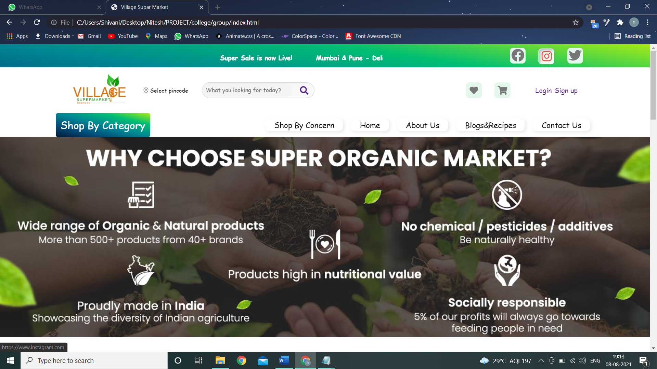

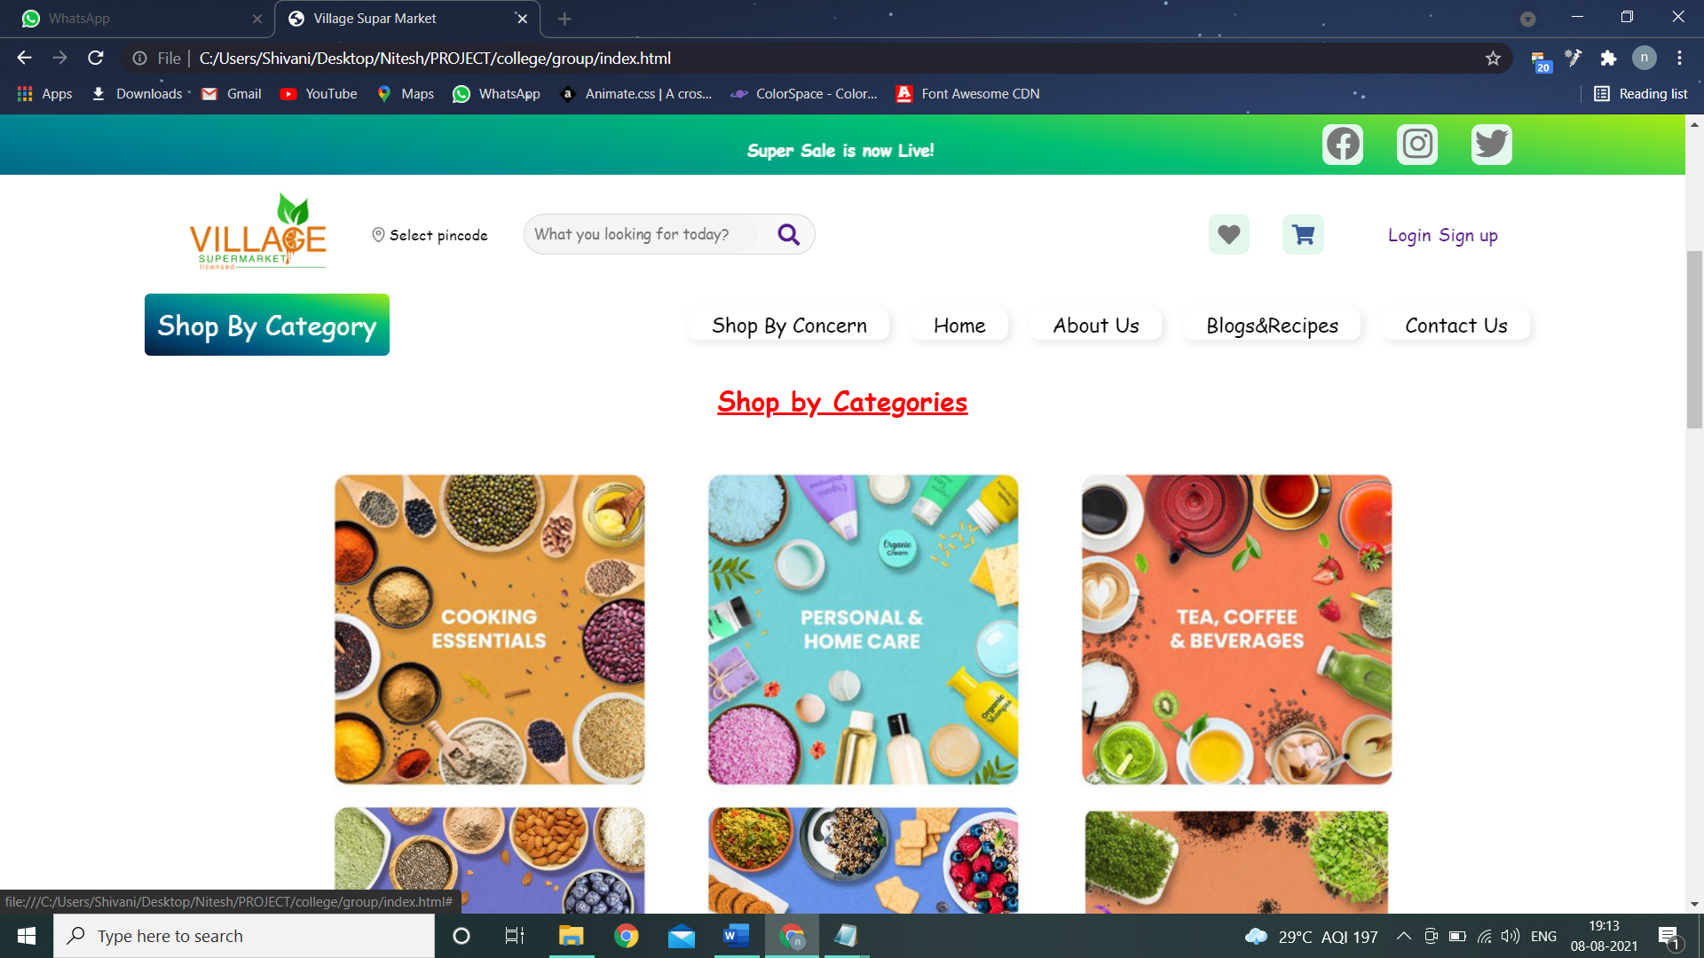

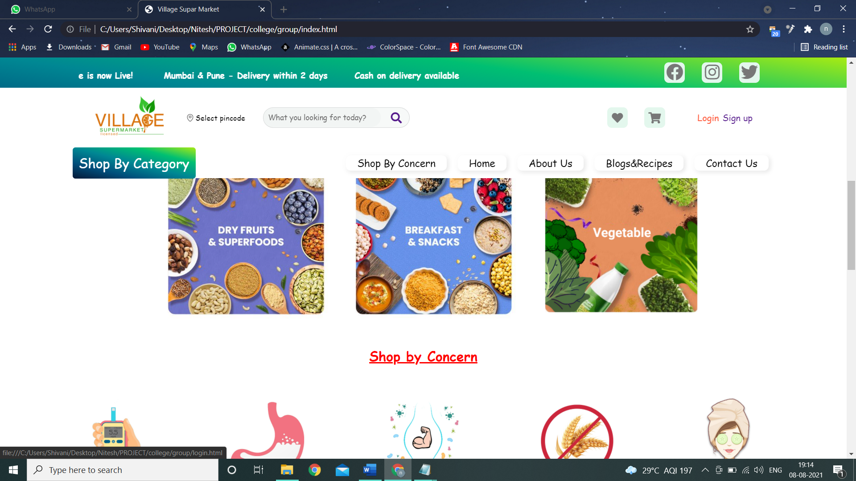

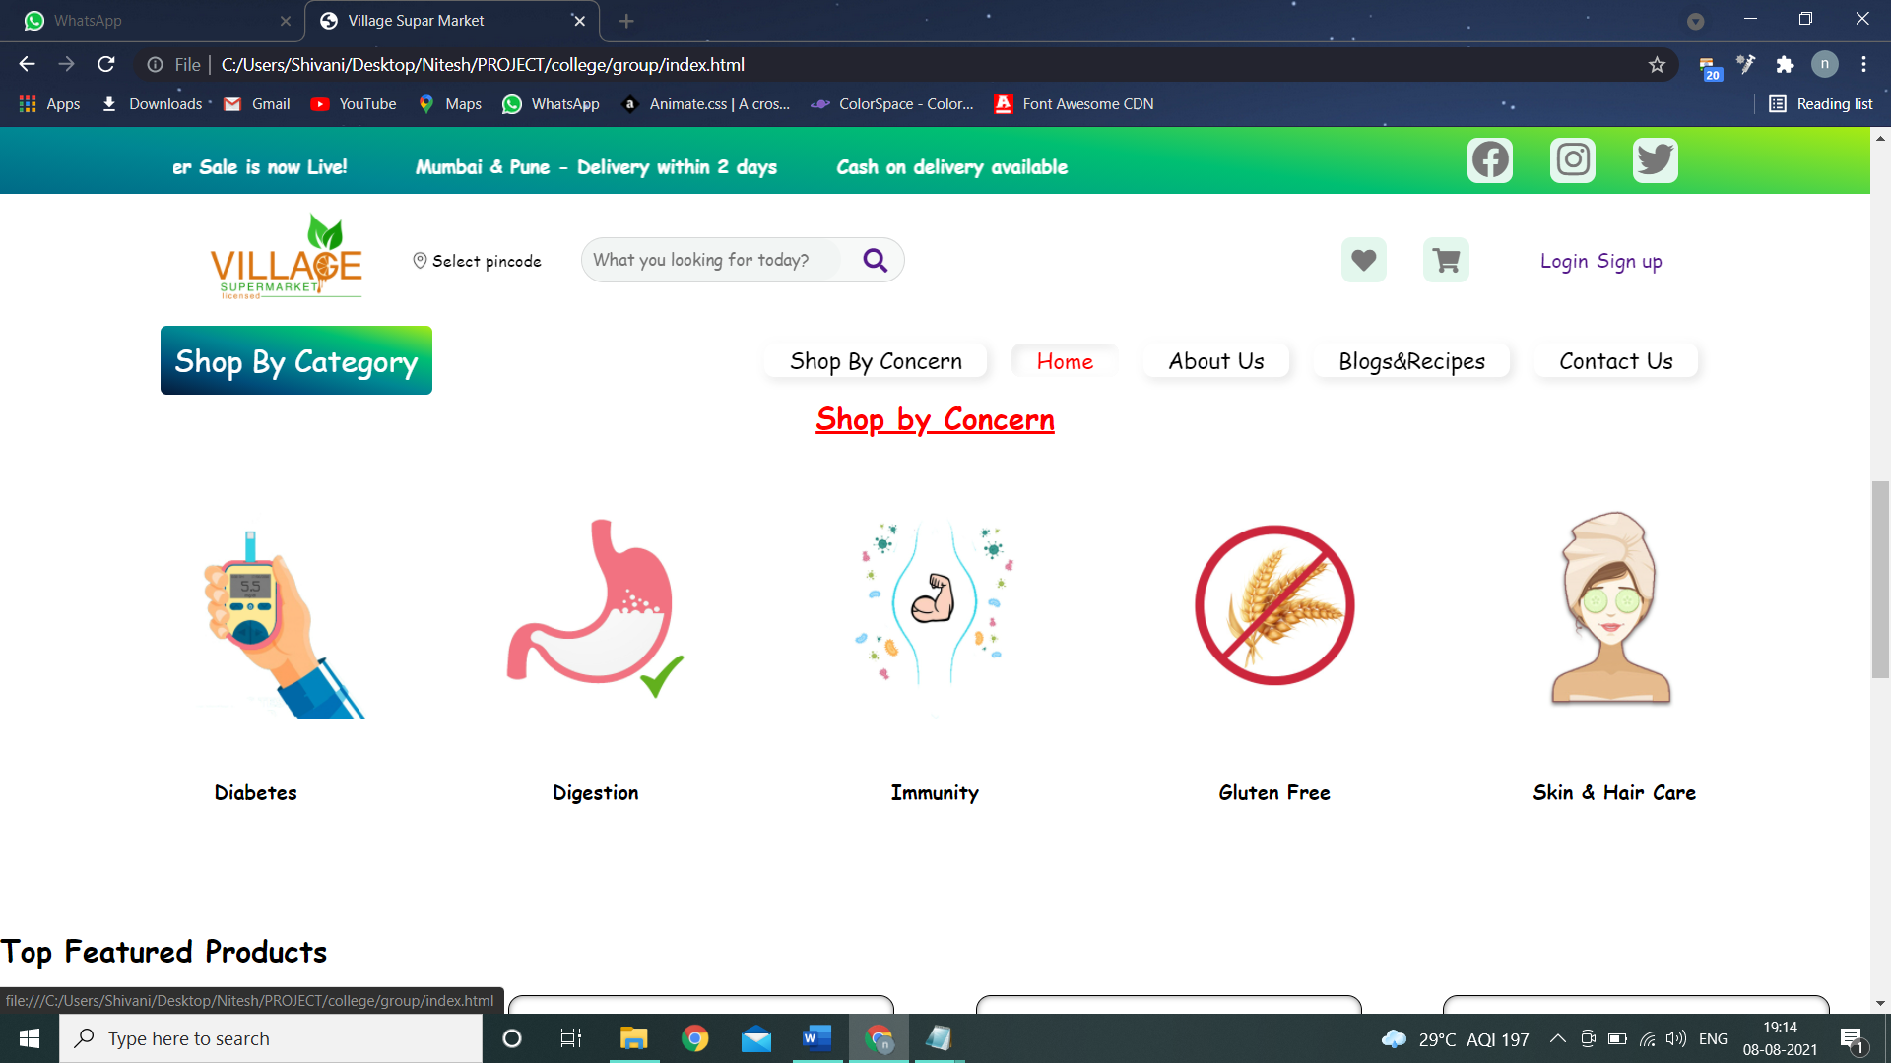

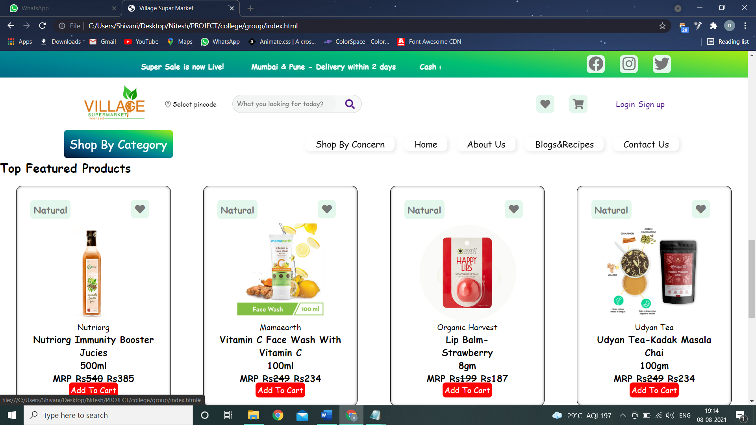

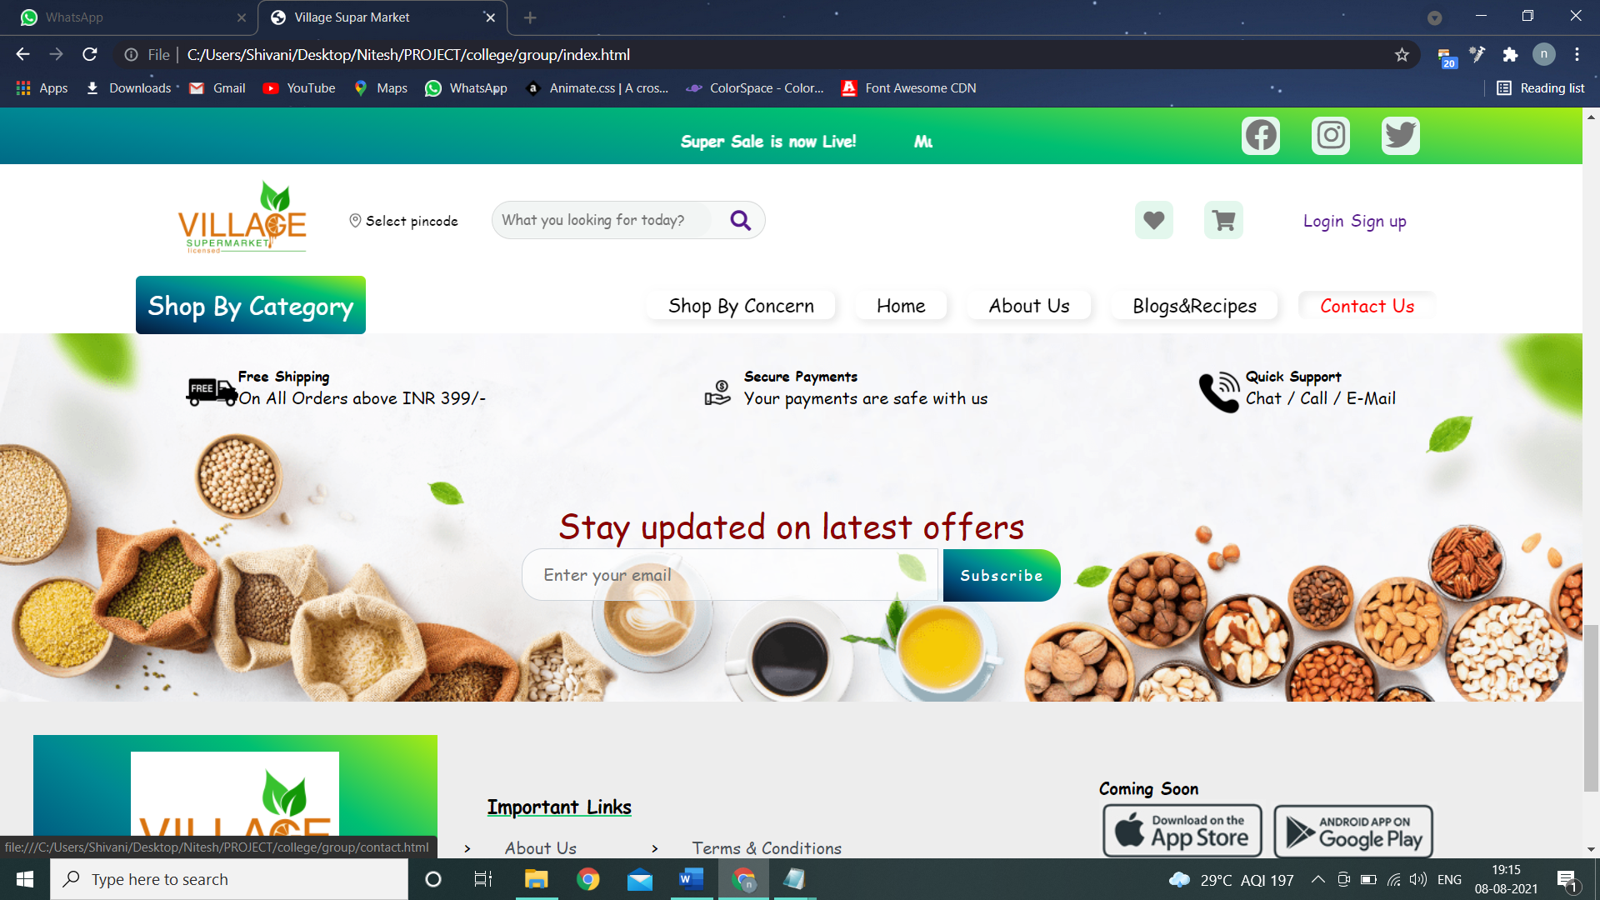

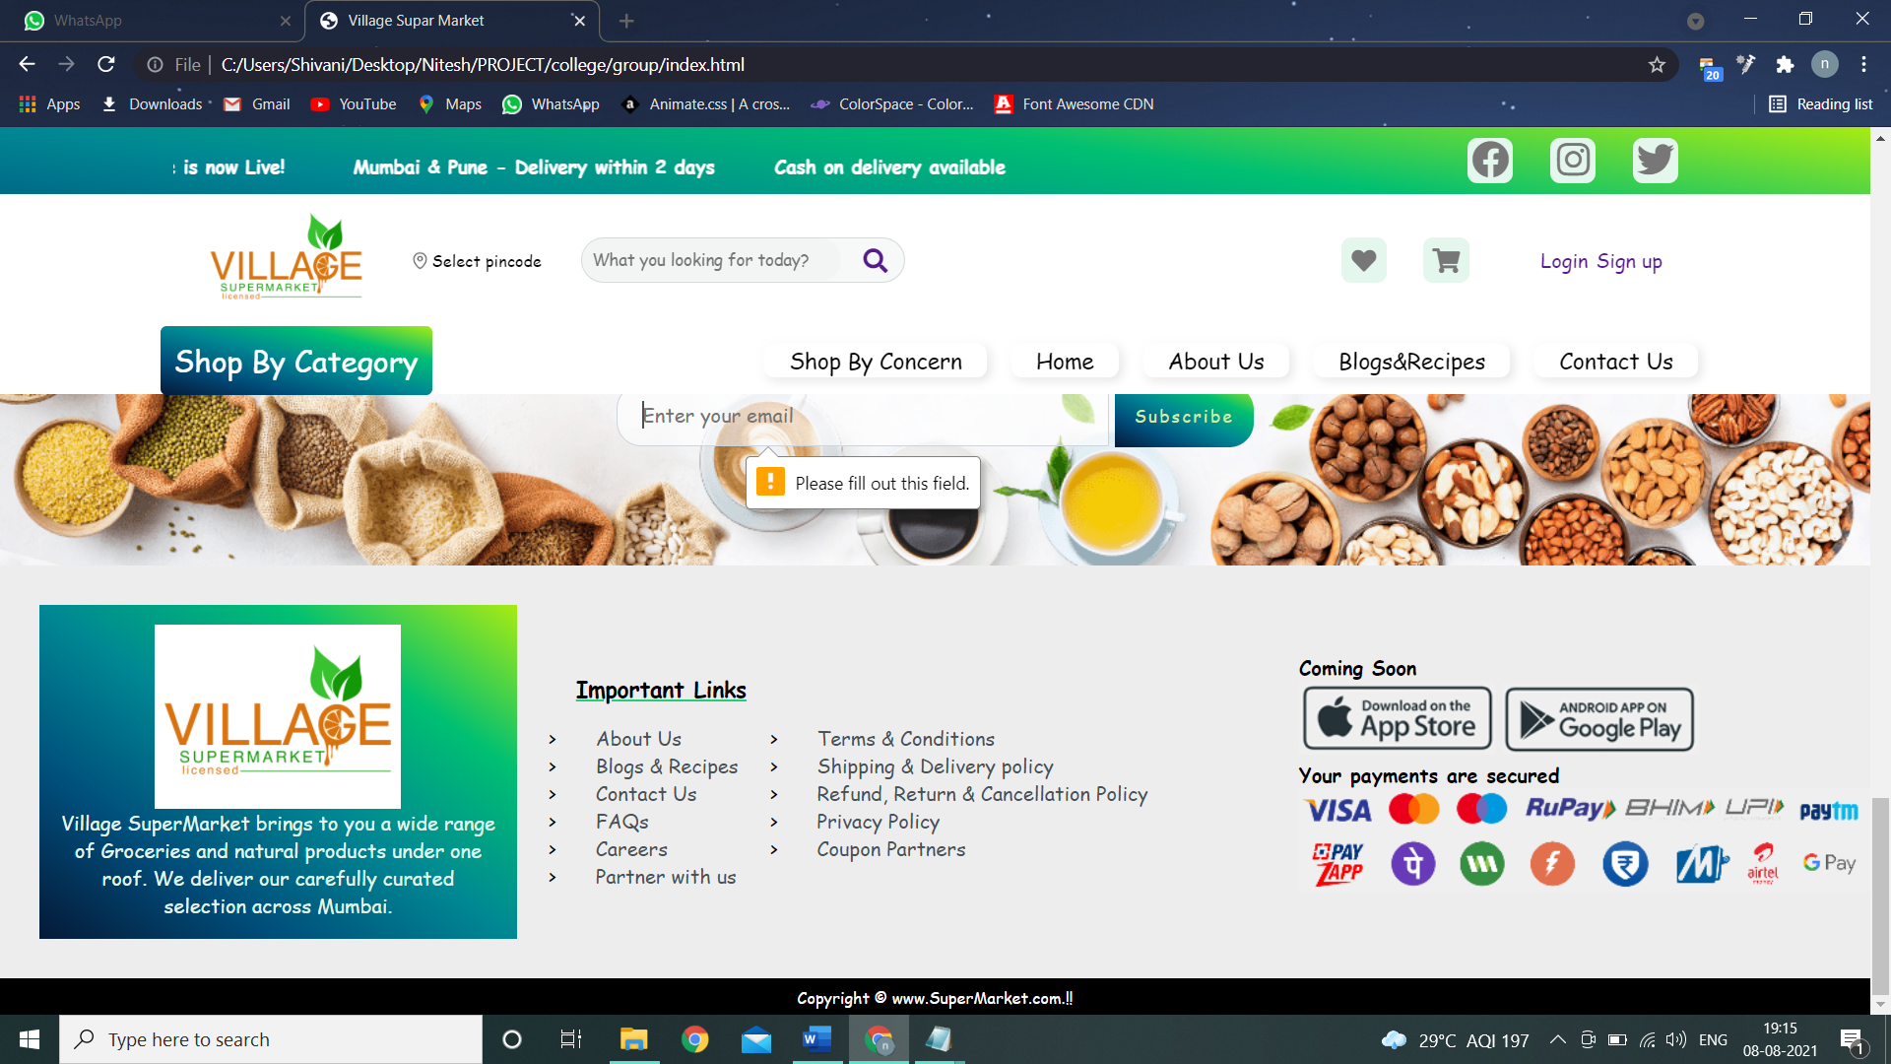

**FOR ABOUT US PAGE**

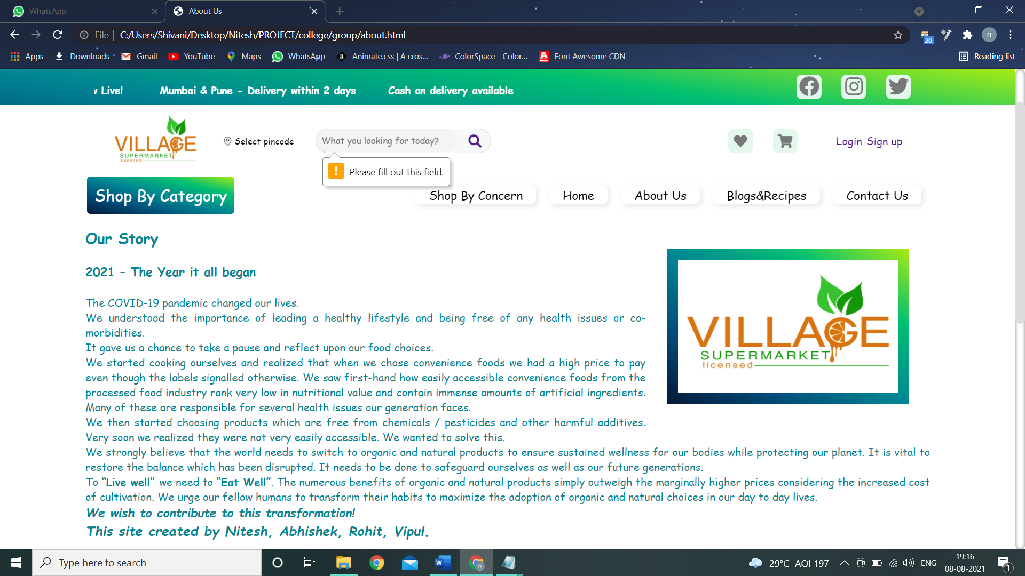

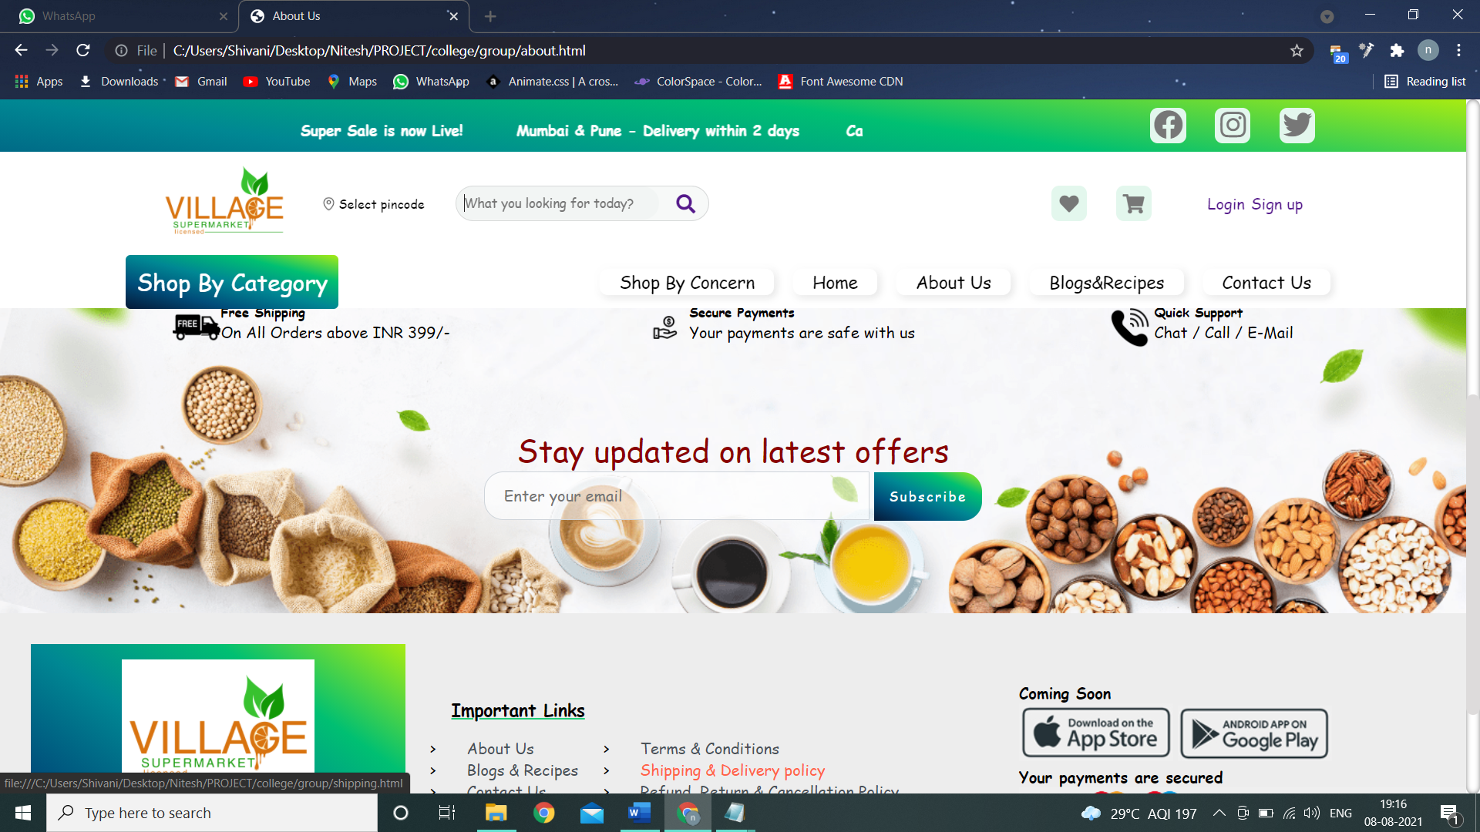

**FOR BLOGS & RECIPES PAGE:**

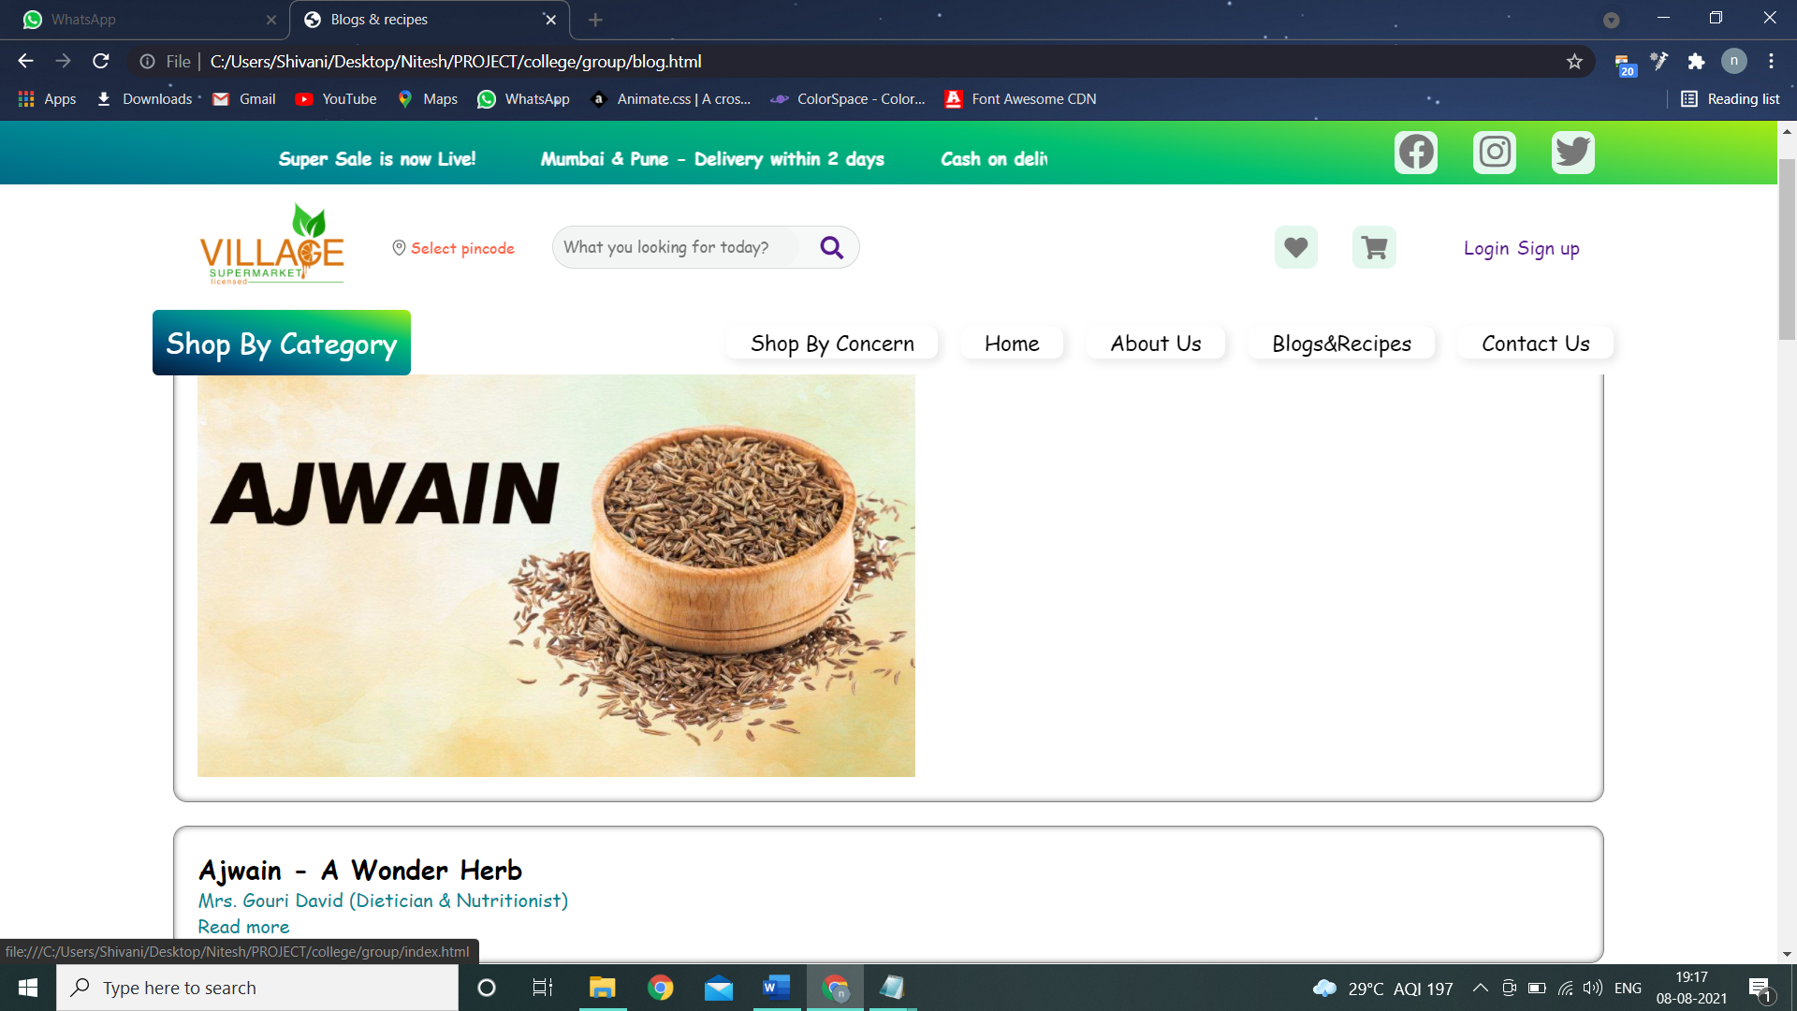

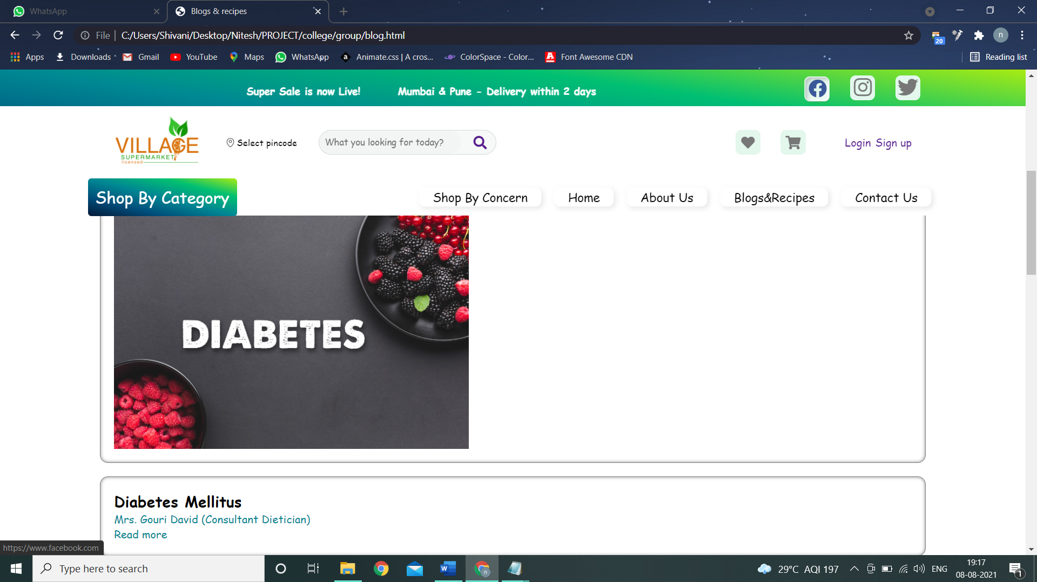

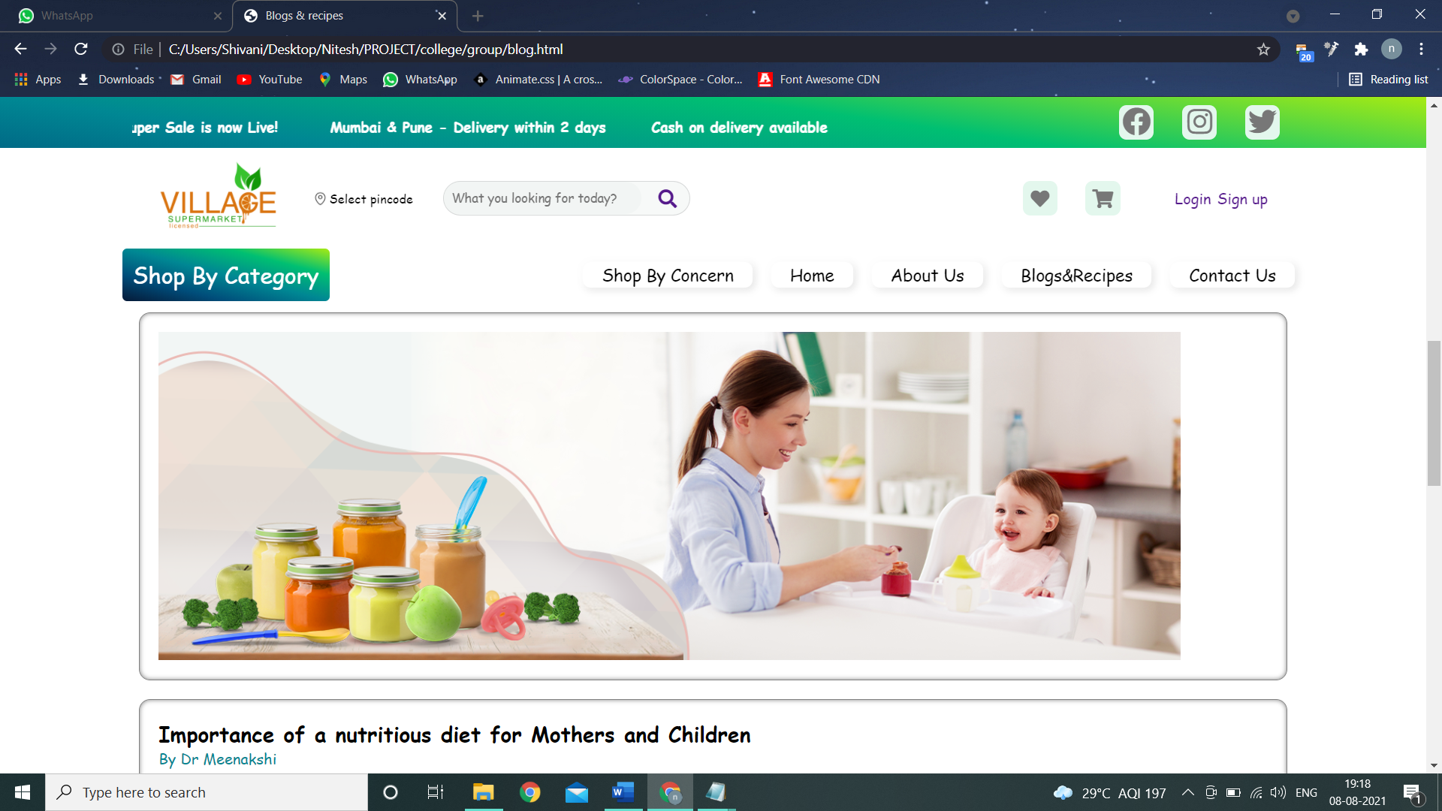

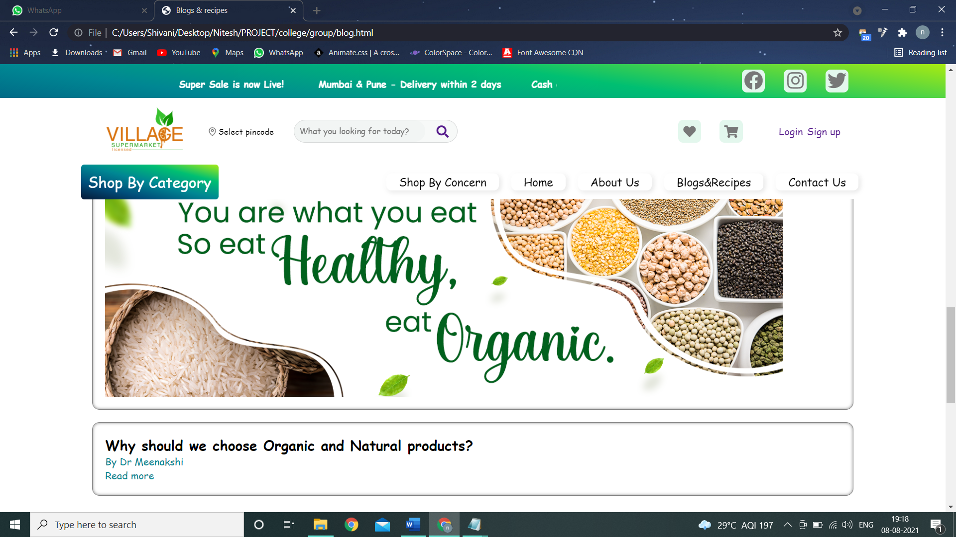

**ADVANTAGES/LIMITATIONS:**

**ADVANTAGES OF HTML AND CSS**

Using HTML5 and CSS3 provides advantages to businesses that develop and deploy web content and web applications, to create refined and accurate web pages and web systems that operate across devices, operating systems and web browsers. Write once, run anywhere. The plethora of devices, operating systems and screen sizes present numerous design, functional and layout considerations and problems if standards are not adhered to.

CSS handles the design and feel a part of an internet page. Using CSS, you will control the color of the text, the design of fonts, the spacing between paragraphs, how columns are sized and laid out, etc. CSS instructs the display of the HTML on how the web site will display at the user's end.

**LIMITATIONS OF HTML AND CSS:**

CSS cannot perform any logical operations like if/else or for/while or +/-.

We can not read any files using CSS.

It can not interact with databases.

CSSCSS cannot perform any logical operations like if/else or for/while or +/-.

We can not read any files using CSS.

It can not interact with databases.

CSS can not request a web page. can not request a web page.